
Available online at www.sciencedirect.com
SCIENCE tft) DIRECT
Computer Communications 29 (2006) 820-826

www.elsevier.com/locate/comcom
Efficiency and quality of service issues in MPLS transport for the UMTS access network
Enrique Vazquez*, Manuel Alvarez-Campana, Ana B. Garcia, Alberto Hernandez
Department of Telematics, Technical University of Madrid, ETS Ing. Telecomunicacion, Ciudad Universitaria, 28040 Madrid, Spain
Available online 12 September 2005
Abstract
Multiprotocol Label Switching (MPLS) offers a simple and flexible transport solution for multiservice networks, and many operators are currently using or considering the use of an MPLS backbone. In UMTS networks, MPLS can be used both in the access part (i.e. the links that provide connectivity to each base station) and in the core. However, the efficient transport of short voice and data packets in the UMTS access network requires multiplexing and segmentation functions not provided by MPLS. This paper investigates the use of ATM Adaptation Layer 2 (AAL2) over MPLS to perform both functions. The efficiency of AAL2/MPLS is analyzed for different traffic types and compared with other transport options. The results indicate that significant capacity savings can be obtained with this solution. © 2005 Elsevier B.V. All rights reserved.
Keywords: MPLS; UMTS; ATM Adaptation Layer 2; Transport efficiency
1. Introduction
The 3G Universal Mobile Telecommunications System (UMTS) is a network designed to support multiple applications (telephony, video-conferencing, audio and video streaming, games, Web access, e-mail, etc.) with very different traffic patterns and quality of service (QoS) requirements. The initial UMTS architecture defined by the Third Generation Partnership Project (3GPP) comprises a Wideband CDMA radio interface, an access network based on Asynchronous Transfer Mode (ATM), and a core network evolved from 2G networks. The core has two domains. The circuit-switched domain, founded on GSM, handles voice and other circuit-mode traffic. The packet-switched domain, derived from GPRS, handles IP traffic. This structure, described in the 3GPP Release 99 specifications, is progressively changing towards a unified architecture based on IP (Releases 4, 5, and 6).
* Corresponding author. Tel.: + 34 91 336 7330; fax: +34 91 336 7333. E-mail addresses: enrique@dit.upm.es (E. Vazquez), mac@dit.upm.es (M. Alvarez-Campana), abgarcia@dit.upm.es (A.B. Garcia), albertoh@dit. upm.es (A. Hernandez).
In contrast with the core network, the UMTS Terrestrial Radio Access Network (UTRAN) relies on an integrated transport infrastructure for all traffic types (voice, data, etc.). The UTRAN protocol stack is divided into a Radio Network Layer (RNL), designed specifically for UMTS, and a Transport Network Layer (TNL) that reuses existing transport technologies. In Releases 99 and 4, the TNL consists of ATM connections, with either ATM Adaptation Layer type 2 (AAL2) or 5 (AAL5) depending on the interface considered. Release 5 specifications [1,2] allow two TNL alternatives: ATM, as before, or IP with UDP (User Datagram Protocol) for user information and SCTP (Stream Control Transmission Protocol) for signalling. IP version 6 is mandatory and IP version 4 is optional.
1.1. Problem statement
The UTRAN faces challenging requirements. Installing a high number of base stations (called Node Bs) and providing links to each of them is a major part of the network cost, so the available transmission capacity must be utilized efficiently. Typically, the last hop to each Node B will be the bottleneck in terms of capacity. Therefore, minimizing the protocol overhead in the interface between the Node B and the rest of the network (called Iub in the UMTS terminology) becomes an important design issue.
Two main problems must be solved. Firstly, multi-layer protocol stacks add a large overhead to voice packets. For example, the AMR (Adaptive Multi-Rate) voice codec at 12.2kbit/s generates payloads of 32 bytes during activity periods, and 5 bytes during silence periods, whereas the total size of the headers added by each protocol layer can easily be higher than those values. This problem can be alleviated by using header compression algorithms and by multiplexing voice communications. In this way, several short voice packets are concatenated before transport, so the overhead of the headers added after the concatenation is shared by all the packets in the group. Secondly, long packets may introduce unacceptable delay variations when transmitted over a slow link. To avoid this, packets that exceed a certain maximum size are segmented before transmission. Note that segmentation reduces efficiency, but it may be necessary to meet QoS requirements (delay variation).
1.2. Paper organization
The rest of this paper is organized as follows. Section 2 analyzes the transport alternatives in the UTRAN in more detail, and reviews various solutions proposed to implement concatenation and segmentation in the Iub protocol stack. Section 3 presents a new proposal that relies on AAL2 [3] for packet concatenation/segmentation, and Multiprotocol Label Switching (MPLS) [4] for transport. The rationale of this approach is given and its advantages related to simplicity, scalability, and interoperability are discussed. Section 4 evaluates the performance of AAL2/MPLS for voice and data, and compares it with other options, confirming that it achieves high efficiency and low delay. Finally, Section 5 summarizes the contributions of the paper.
2. Alternatives for transport in the UTRAN
Figure 1 gives an overview of the UMTS architecture, focusing on the UTRAN and the Iub interface between the
Node B and Radio Network Controller (RNC). ATM in the
UTRAN is studied in [5] and [6], including traffic modeling,
QoS analysis, and simulation experiments with voice and data traffic. The 3GPP has investigated IP transport in the UTRAN in an ad hoc group created within the Technical Specification Group Radio Access Network, Working
Group 3 (TSG RAN WG3), which is responsible for the
overall UTRAN design. A technical report [7] presents the conclusions of this work and makes some general recommendations for Release 5 specifications.
Different Iub stacks based on IP are simulated and compared in [8]. The concatenation and segmentation functions mentioned in the previous section may be located above UDP/IP or below it. Protocols such as Composite IP (CIP) and Lightweight IP Encapsulation (LIPE) [9] concatenate and, optionally, segment packets above UDP/ IP. Alternatively, both functions may be implemented at layer 2 by using PPPmux [10] for concatenation, and the
multi-class, multi-link extensions to PPP (MC/ML-PPP)
[11] for segmentation. This is the option recommended by 3GPP in [7]. The application of the IETF Differentiated Services model in the UTRAN is addressed in several studies. For example, in [12] voice calls are multiplexed with CIP and transferred with the Expedited Forwarding Per-Hop Behavior [13].
While these studies indicate that IP can be a viable alternative to ATM for the UTRAN, it is necessary to implement a complicated protocol stack to achieve the required performance. First, UDP/IP headers have to be compressed to reduce the overhead added to short packets (e.g. voice). Many compression algorithms have been proposed, for example IP Header Compression, Compressed RTP, Enhanced Compressed RTP, Robust Header Compression, and others described in RFCs or Internet drafts. For references and a discussion of the advantages and drawbacks of each method see [7]. PPP encapsulation and framing overhead must also be minimized by using the simplified header formats foreseen in the standard.
Second, PPPmux and MC/ML-PPP must be
implemented. When there are intermediate IP routers
between Node B and RNC, PPPmux and MC/ML-PPP
may be terminated at the edge router (ER) next to the Node B or at the RNC. In the former case, header compression,
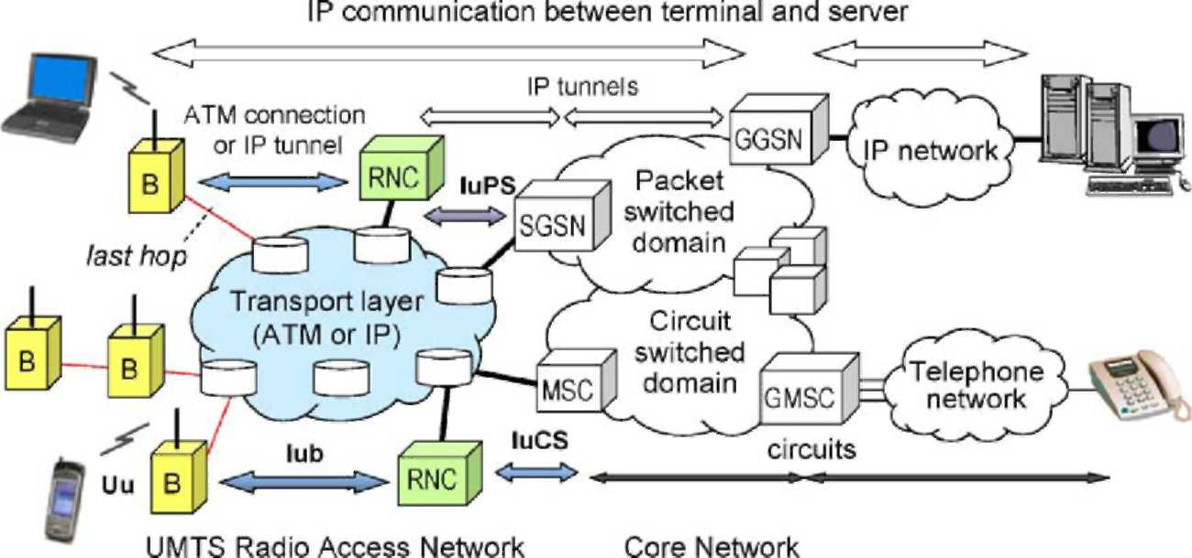
Fig. 1. Overview of transport in UMTS.
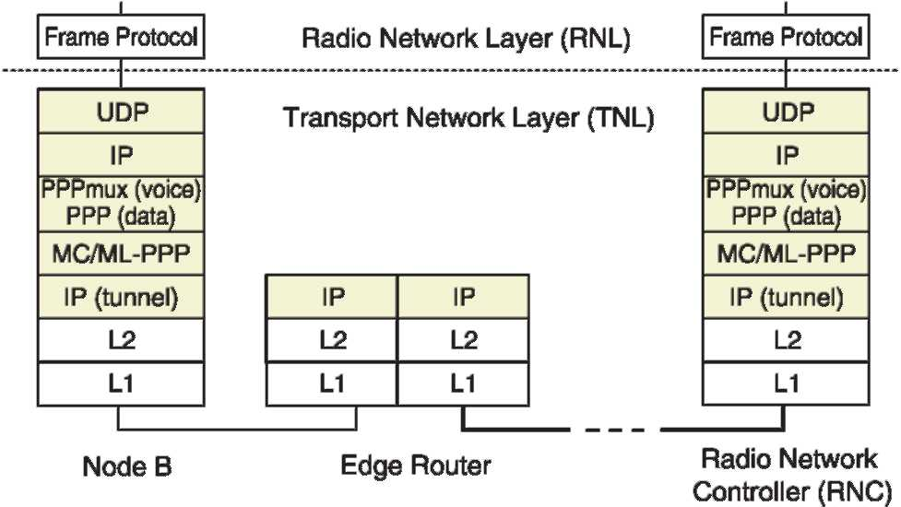
Fig. 2. UDP/IP transport stack in the user plane of the Iub interface, with end-to-end concatenation/segmentation between Node B and RNC.
concatenation, and segmentation are applied only in the last hop between the Node B and the ER, where capacity is likely to be more limited. Packets are routed individually between the ER and the RNC. In the latter case, those functions are moved to the RNC, so the efficiency gains are maintained all the way up to the RNC. The disadvantage of this approach is that layer 2 frames must be tunneled between the Node B and the RNC. This implies that another IP header is added to the information transported across the network. See Fig. 2.
The Radio Network Layer (RNL) includes other protocols not shown in Fig. 2, namely Medium Access Control, Radio Link Control, and Packet Data Convergence Protocol. Non-access stratum protocols, which are transparent for the UTRAN, are located on top of the RNL, for example IP packets exchanged between the user equipment
and the Gateway GPRS Support Node (GGSN) in the
UMTS core network, plus the higher layer protocols required by the user applications (TCP, HTTP, etc.). With the architecture of Fig. 2 these IP packets would be encapsulated with two additional IP headers, resulting in a poor efficiency.
The use of MPLS in the UTRAN has been considered mainly in terms of protocol functionality, for example: mapping of traffic flows to MPLS Label Switched Paths (LSPs) and signalling for LSP establishment [14], combination of MPLS traffic engineering (MPLS-TE) functions with the Differentiated Services model (DiffServ) [15], and mobility support [16,17]. These references point out
potential advantages of MPLS for transport in the UTRAN, but no numerical results are presented.
The MPLS/Frame Relay Alliance (MFA) has defined an ad hoc multiplexing protocol for efficient transport of voice calls over MPLS [18], and a protocol for emulating TDM circuits that uses AAL1 over MPLS [19], but they are not adequate as a general solution for voice and data transport in
the UTRAN.
3. AAL2/MPLS transport in the UTRAN
This section introduces a simple TNL architecture with two main components: AAL2 and MPLS. Specifically, we propose to use the Common Part Sublayer (CPS) of AAL2 [20] plus the Service Specific Segmentation and Reassembly (SSSAR) sublayer [21] (See Fig. 3). The MFA implementation agreement for voice trunking over MPLS [22] uses CPS too, but the rest of the protocol stack is different from the one defined here. This agreement includes the convergence sublayer for trunking I.366.2 [23] and an intermediate header called A2oMPLS (AAL2 over MPLS) between the MPLS label stack and the CPS packets. Instead
of I.366.2 and A2oMPLS, our proposal uses SSSAR only,
which implements segmentation, reduces the overhead, and is more adequate for integrated voice and data transport than
I.366.2.
Our solution, explained in more detail below, combines standard protocols in such a way that each one performs the essential function it was designed for, and complements the other (see Fig. 4). AAL2 is used to multiplex many variable-bit-rate, delay-sensitive traffic flows [3],and MPLS provides a flexible tunnelling mechanism without the overhead of ATM. The result is a simple protocol architecture that offers significant advantages in comparison with other solutions (see Section 3.1).
The CPS concatenates voice and data packets. Each CPS packet has a 3-byte header and a maximum payload length of 45 (default) or 64 bytes (See Fig. 5). The SSSAR sublayer accepts data units up to 65,568 bytes and segments them up to the maximum length admitted by CPS. The last segment of each packet is marked in the UUI bits of the CPS header,
so the SSSAR adds no extra overhead. CPS and SSSAR are
used in ATM-based UTRANs as defined in Release 99 and
Fig. 3. AAL2 components used in AAL2/MPLS.
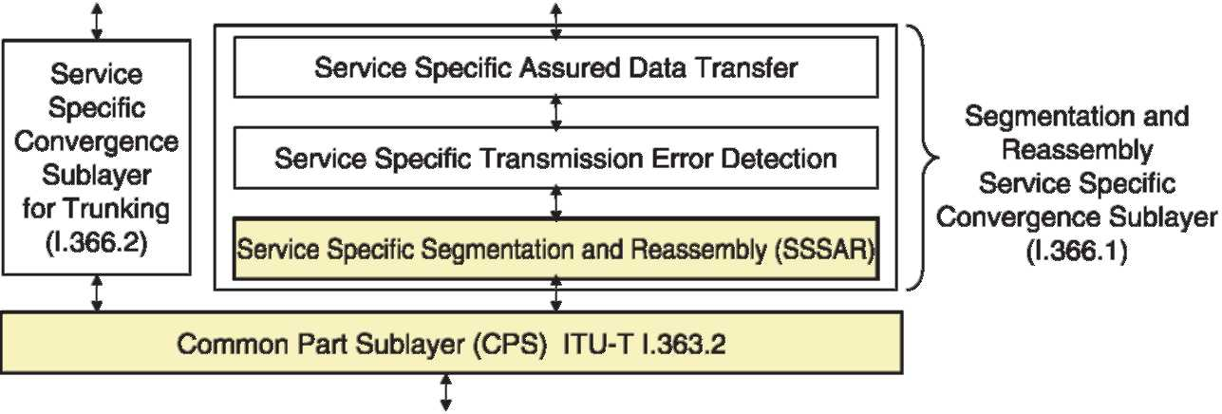
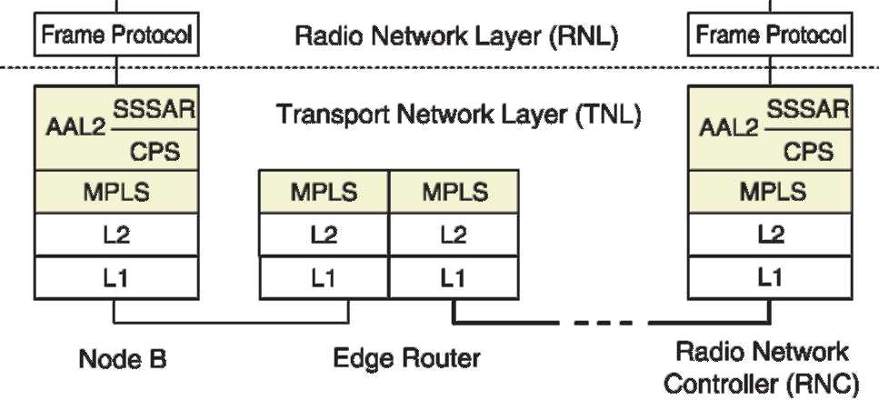
Fig. 4. AAL2/MPLS transport protocol stack in the user plane of the Iub interface.
Release 4 specifications. CPS packets are mapped to cells sent over ATM virtual connections at the Iub interface. The first byte of each cell payload, called Start Field, indicates the next CPS packet boundary. The time that a partially filled cell waits for the next CPS packet is limited by Timer_CU (Combined Use). If it expires, the cell is completed with padding bytes and transmitted.
In the proposed AAL2/MPLS solution, AAL2 performs the same functions as in the AAL2/ATM case, except that CPS packets are not mapped to cells. They are concatenated up to Timer_CU expiration or up to a given maximum length Lmax (e.g. set to comply with a maximum transmission time in the Node B—Edge Router link), and transmitted over an LSP preceded by the MPLS label stack. CPS payloads contain Frame Protocol data units, segmented by SSSAR if necessary.
3.1. Advantages of AAL2/MPLS
AAL2/MPLS is conceptually very similar to AAL2/ATM. ATM virtual connections and related traffic management procedures are replaced by MPLS LSPs, possibly supporting traffic engineering and class-of-service differentiation (DiffServ-Aware MPLS Traffic Engineering or DS-TE) [24]. AAL2/MPLS is considerably more efficient, because the ATM cell header overhead is eliminated. See the results presented in Section 4.
The AAL2 protocol is implemented only at the end points (Node B and RNC), and intermediate ATM switches are not needed. Since AAL2 is still used, the interface offered by the Transport Network Layer to the Radio Network Layer is the same as in UMTS Releases 99 and 4. Moreover the standard signalling procedures used to
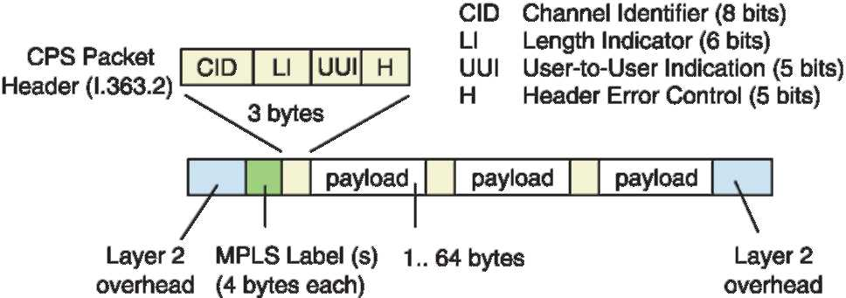
Fig. 5. Concatenated AAL2 CPS packets over MPLS.
establish and release AAL2 channels (Access Link Control Application Part, ALCAP) can be reused.
Compared with IP-based alternatives, AAL2/MPLS is simpler. IP tunnels, header compression, PPP multiplexing, and Multi-Class Multi-Link PPP are not required in the TNL (although IP is still used by applications in the non-access stratum, as mentioned in Section 2). Regarding efficiency, AAL2/MPLS compares to the best IP based solutions, with values in the 90-95% range, as shown in Section 4.
4. Performance evaluation
The header formats and procedures of the different protocols mentioned in the preceding sections have been analyzed in order to evaluate the efficiency of alternative transport stacks for the UTRAN. The analysis considers a simple case where every concatenated packet has the same length. The results presented in Sections 4.1 and 4.2 show the improvements that can be obtained with the AAL2/
MPLS solution.
A higher transport efficiency should allow the network to carry more traffic maintaining the QoS levels or, alternatively, to reduce the capacity needed to carry a given amount of traffic with the required QoS. To verify this assumption, we have simulated in more detail each protocol stack, transporting various mixes of voice and Web data traffic in the Iub interface between base stations (Node Bs) and controllers (RNCs). Optimizing this interface is particularly important for the operators due to the high number of Node Bs that must be connected in a typical UMTS network, so we focused the simulation study on it. However, the solution proposed here can be used in other UMTS interfaces as well. Section 4.3 gives a sample of the simulation results obtained.
4.1. Analysis of efficiency for voice traffic
In this case, we analyze the transport of voice payloads of constant size P = 40 bytes, corresponding to 32 bytes generated the Adaptive Multi Rate codec used in UMTS, plus 8 bytes added by the RNL [5]. The background noise description packets sent by the AMR codec during silence periods are not considered in the analysis. The number of concatenated packets per group (N) is equal to the number of voice connections in the active state. Segmentation is not necessary.
The overhead per packet (H) and the overhead per group (H_{g}) take different values depending on the transport protocol stacks considered. For example, AAL2/MPLS over PPP with simplified HDLC framing
(AAL2/MPLS/PPP/ HDLC) gives H= 3 bytes and Hg=
9 bytes. UDP/IP with headers compressed to 4 bytes and concatenation at layer 2 (cUDPIP/PPPmux/HDLC) gives H= H_{g}= 5 bytes. The details of the model and the complete set of parameter values used can be found in [25].
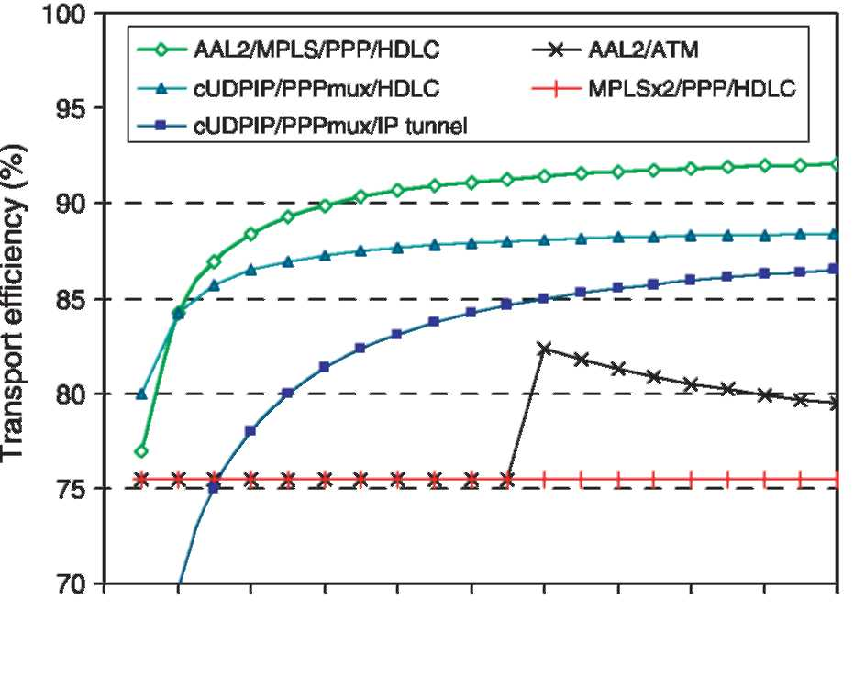
0 2 4 6 8 10 12 14 16 18 20
Active voice calls
Fig. 6. IP and MPLS transport options vs. AAL2/ATM (voice traffic).
Figure 6 shows the efficiency (number of RNL bytes transported divided by the total number of bytes transmitted by the TNL) as a function of the number of active voice connections. The best alternative is AAL2/ MPLS, with efficiency above 90% even for moderate values of N. The efficiency of UDP/IP with headers compressed to 4 bytes (cUDPIP) over PPPmux is not as good, because concatenation at layer 2 gives a higher overhead per packet (H). If the end-to-end configuration between Node B and RNC illustrated in Fig. 2 is used, the extra IP tunnel increases the overhead per group (H_{g}) and reduces the efficiency, especially when there are few packets per group.
The curve labeled MPLS X 2/PPP/HDLC corresponds to the case where AAL2 is not used and each packet is transmitted with a stack of two MPLS labels: the inner label is used as a channel identifier, and the outer one serves to route the packets to their destination. The two labels (4 bytes each) plus the PPP/HDLC header add a total of 13 bytes to each voice payload of 40 bytes. Therefore, the efficiency is 40/53 = 75.5%, which happens to be the same value obtained with AAL2/ATM when N voice payloads (NX 40 bytes) are transmitted in N ATM cells (NX 53 bytes). This is true for N! 12. When N= 12, 12 voice payloads are carried in 12 concatenated CPS packets (12X43 = 516 bytes), which still fit in 11 cells (11X47 = 517 bytes), so the efficiency of AAL2/ATM increases to 12X 40/11 X 53= 82.3% as shown in Fig. 6.
Other transport options not shown in the graph give poor results. For example, the efficiency of a simple UDP/IP/PPP/HDLC stack without header compression and no multiplexing is only 55.6%. This value corresponds to IP version 4 headers (20 bytes). With IP version 6 headers (40 bytes) it would be even lower: 43.5%. If IP is sent
over AAL5/ATM instead of PPP/HDLC, each voice
packet is encapsulated in 2 cells and the efficiency drops
further to 37.7%.
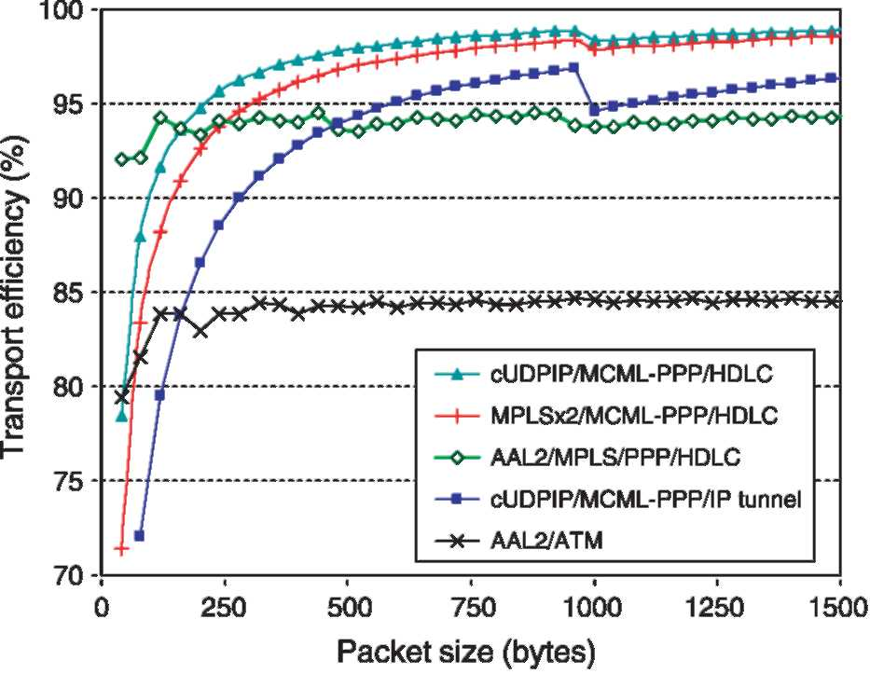
Fig. 7. IP and MPLS transport options vs. AAL2/ATM (data traffic). 4.2. Analysis of efficiency for data traffic
Figure 7 shows the transport efficiency for data payloads of variable size P up to 1500 bytes. As explained in previous sections, short packets may be concatenated up to a maximum size Lmax, and packets longer than Lmax are segmented before transmission. In Fig. 7 Lmax has been set to 1000 bytes. H is the overhead per packet or segment and H_{g} is the overhead per group, with different values for each protocol stack as in the previous case.
AAL2/ATM is included for reference, as in the previous graph. With ATM, long packets are segmented into several cells. The maximum efficiency in this case is
64 X 47/(67 X 53) = 84.7%, well below that of the other transport options.
With compressed UDP/IP (cUDPIP) and MPLS using a 2-label stack (MPLSX 2), segmentation is done at layer 2 by MC/ML-PPP. Both exhibit a high efficiency for long data packets, although they were not as good for short voice packets (compare the corresponding curves in Figs. 6 and 7). In MPLS X 2, the internal label identifies each data channel, and the external one is used for routing. AAL2/MPLS reaches approximately the same value, close to 95%, for both voice and data. In this case, MC/ML-PPP is not needed because AAL2 takes care of segmentation at the SSSAR
sublayer, so AAL2/MPLS uses the default PPP/HDLC
encapsulation.
Figure 7 indicates that MPLSX 2 outperforms AAL2/ MPLS for packets longer than 250 bytes approximately. Therefore, in scenarios where the traffic mix includes significant amounts of short voice packets (a few tens of bytes) and long data packets (a few hundreds of bytes or more), the overall efficiency can be optimized by separating the traffic of each Node B in two Label Switched Paths: LSP 1 for voice with AAL2, and LSP 2 for data without it. See case b) in Fig. 8.
Assuming that voice packets are always smaller than
65 bytes, the SSSAR part of AAL2 can be removed in LSP
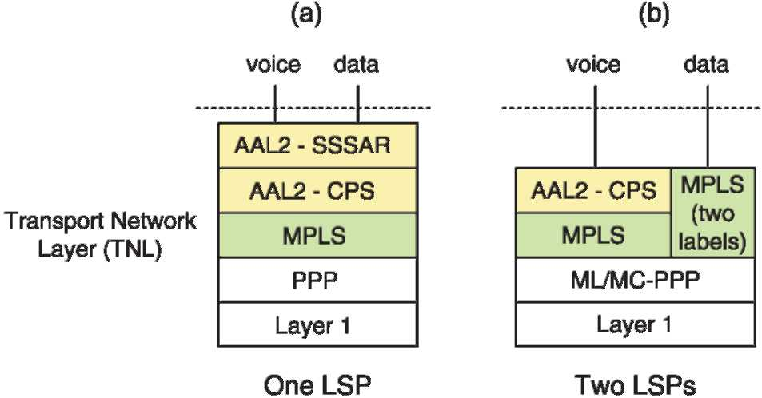
Fig. 8. AAL2/MPLS with one (a) or two (b) LSPs.
1. Packets sent via LSP 2 are segmented, if necessary, by Multi-Class Multi-Link PPP. Note that the network operator may prefer to use separate LSPs for voice and for data anyway, even if AAL2 is used in both.
4.3. Simulation results
The Iub transport protocol stacks considered in the preceding sections have been simulated with voice and Web traffic, in order to compare the delay and loss performance of the different options. The traffic source modules generate Frame Protocol data units (see Figs. 2 and 4). The data unit sizes and inter arrival times are set taking into account the relevant characteristics of the UMTS radio access bearers used, as well as the overheads added by the RNL protocols. The transmission rate and the Transmission Timing Interval (TTI) are the most decisive parameters. In our simulations, voice is coded at 12.2 kbit/s with TTI = 20 ms. Including the RNL overhead, this corresponds to one FP data unit of 40 bytes every 20 ms. During silence periods the data unit size is reduced to 13 bytes. Web pages are downloaded at 64 kbit/s with TTI = 40 ms, which corresponds to one data unit of 331 bytes every 40 ms, also including RNL overhead. For AAL2/MPLS, the simulator can be configured to use the same LSP for all traffic, or separate LSPs for voice and for data. In these experiments we chose the latter option.
Figure 9 is a sample of the results obtained. The curves show the Iub delay (0.95- or 0.99-quantile) vs. the number of active users. The capacity available for user traffic is set
to 1.92 Mbit/s, and delays are measured in the RNC-to-Node B direction (Web traffic is higher in this direction). As anticipated by the previous analysis of efficiency, AAL2/ MPLS gives the lowest delay for voice. MPLS without AAL2 is a good option for data traffic (right) but not for voice (left), because it gives a much higher delay than the other options. For a given maximum delay in the Iub interface, these curves may be used to estimate the number of users that can be served with the available capacity. A detailed description of the simulated scenarios and additional results can be found in [5,25].
5. Conclusions
The UMTS transport layer is expected to migrate from ATM to packet-switched architectures that can provide the required quality of service at a lower cost. In this scenario,
AAL2 (with SSSAR and CPS) over MPLS is a simple
solution that offers a functionality similar to ATM, but in a more flexible and efficient way.
This paper has discussed the main issues in transporting voice and data traffic to base stations connected with low capacity links, and has compared the performance of AAL2/MPLS with other proposals, both analytically and by simulation. AAL2/MPLS is more efficient than AAL2/ATM (typical differences are between 12 and 20%), so a larger fraction of the available capacity is dedicated to carry user traffic, and more customers can be served with the required QoS. AAL2/MPLS is particularly well suited for short packets, which are the most affected by protocol overhead. In fact, the efficient transport of small delay-sensitive packets was the main goal of the AAL2 protocol design.
As explained in the paper, AAL2 channels and its associated signalling procedures are terminated in the UTRAN equipment (Node Bs and RNCs), so intermediate ATM switches are not needed. For operators that have deployed ATM networks and want to migrate to IP/MPLS, keeping AAL2 minimizes the changes required and facilitates an incremental migration. MPLS paths transport AAL2 packets more efficiently than ATM virtual circuits,
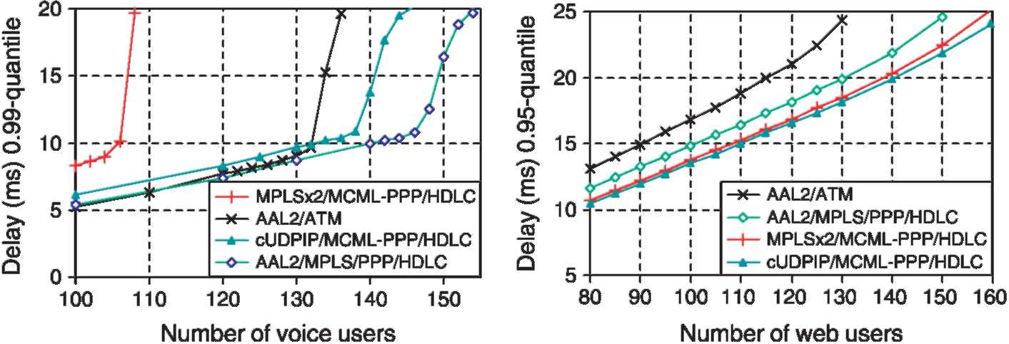
Fig. 9. Simulation of delay at the Iub Interface for different transport options.
offering similar traffic engineering capabilities and better scalability.
References
[1] 3GPP Technical Specification 25.426, v5.2.0, UTRAN Iur and Iub interface data transport & transport signalling for DCH data streams,
Release 5, Sep. 2002.
[2] 3GPP Technical Specification 25.414, v5.4.0, UTRAN Iu interface data transport and transport signalling, Release 5, March 2003.
[3] J. Baldwin, B. Bharucha, B. Doshi, S. Dravida, S. Nanda, AAL2—a new ATM adaptation layer for small packet encapsulation and multiplexing, Bell Labs Technical Journal Spring(1997).
[4] E. Rosen, Multiprotocol label switching architecture, RFC 3031 (2001).
[5] A.B. Garcia Hernando, Dimensioning and Quality of Service Support in the UMTS Access Network, PhD Thesis, Technical University of
Madrid, 2002.
[6] A.B. Garcia Hernando, E. Garcia, M. Alvarez-Campana, J. Berrocal, E. Vazquez, A simulation tool for dimensioning and performance evaluation of the UMTS terrestrial radio access network, Lecture Notes in Computer Science, vol. 2515, Springer, Berlin, 2002.
[7] 3GPP Technical Report 25.933, v5.3.0, IP transport in UTRAN, June
3, 2003.
[8] Research results on UTRAN (RRM, QoS and packet data
compression) phase2, in: A. Gelonch (Ed.), Project IST-1999-10699 Wine Glass, 2001, deliverable D11. [9] J. Kempf, IP in the RAN as a Transport Option in 3rd Generation Mobile Systems, Mobile Wireless Internet Forum, Technical Report
MTR-006, release 2.0.0, June 2001.
[10] R. Pazhyannur, I. Ali, C. Fox, PPP multiplexing, RFC 3153 (2001). [11] C. Bormann, The multi-class extension to multi-Link PPP, RFC 2686
(1999).
[12] K. Venken, D. de Vleeschauwer, J. de Vriendt, Designing a diffserv-capable IP-backbone for the UTRAN, Second International Conference on 3G Mobile Communication Technologies, London, UK
2001.
[13] B. Davie, An expedited forwarding PHB (Per-Hop Behavior), RFC
3246 (2002).
[14] Y. Guo, Z. Antoniou, S. Dixit, IP transport in 3G radio access networks: an MPLS-based approach, IEEE Wireless Communications
and Networking Conference, WCNC 2002, Orlando, FL, March 2002.
[15] L. Feng, QoS Support in IP/MPLS-based Radio Access Networks, Institute for Communications Research (ICR) Seminar, Oct. 2002.
[16] B. Jabbari, R. Papneja, E. Dinan, Label switched packet transfer for wireless cellular networks, IEEE Wireless Communications and,
Networking Conference, WCNC 2000, Chicago, IL, Sept. 2000.
[17] F. Chiussi, D. Khotimsky, S. Krishnan, Mobility management in third-generation all-IP networks, IEEE Communications Magazine 40 (9)
(2002).
[18] MPLS Forum Technical Committee, Voice over MPLS — Bearer Transport Implementation Agreement, MPLSF 1.0, July 2001.
[19] MPLS/Frame Relay Alliance Technical Committee, TDM Transport over MPLS using AAL1, MPLS/FR 4.0, June 2003.
[20] ITU-T Recommendation I.363.2, B-ISDN ATM Adaptation Layer
Specification: Type 2 AAL, Sep. 1997. [21] ITU-T Recommendation I.366.1, Segmentation and Reassembly Service Specific Convergence Sublayer for the AAL type 2, June
1998.
[22] MPLS/Frame Relay Alliance Technical Committee, I.366.2 Voice
Trunking Format over MPLS, MPLS/FR 5.0.0, Aug. 2003.
[23] ITU-T Recommendation I.366.2, AAL type 2 Service Specific Convergence Sublayer for Trunking, Feb. 1999.
[24] V. Fineberg, QoS Support in MPLS Networks, MPLS/FR Alliance 2003.
[25] E. Vazquez, Analysis and Simulation of IP and MPLS Transport in the
UTRAN, Technical University of Madrid, Madrid, 2003.
Enrique Vazquez received his PhD degree in Telecommunication Engineering from the Technical University of Madrid (UPM) in 1987. Presently, he is an associate professor in the Telematics Department of UPM. He has worked in European R&D projects in the ESPRIT, RACE, ACTS, and IST Programmes. His research areas include protocol performance evaluation, traffic engineering, quality of service, MPLS and UMTS. He has co-authored several books, the most recent one in 2003 about broadband access networks.
Manuel Alvarez-Campana is an associate professor in the Telematics Department of UPM. He received his PhD degree in Telecommunication Engineering from UPM in 1995. He has worked in several projects within the framework of European and Spanish R & D programs. His current research interests include performance evaluation, traffic characterization, and quality of service in UMTS networks.
Ana B. Garcia received her Telecommunication Engineering degree from the Technical University of Madrid in 1998 and the PhD degree in 2002 from the same University. She is currently working in the Telematics Department of UPM performing teaching and research activities. Her research interests include advanced traffic analysis in IP backbones and quality of service in 3G mobile communications systems, fields in which she has published several research papers.
Alberto Hernandez received his Telecommunication Engineering degree from the Technical University of Madrid in 2004 and is currently working to obtain his PhD degree in topics related to the IP Multimedia Subsystem
(IMS) of UTMS.

